**P2 – Explain the features of the box model for CSS**

**Introduction**

In this report, I will explain the 4 element of the box model with a diagram of the box model itself.

**Four Elements of Box Model**

* 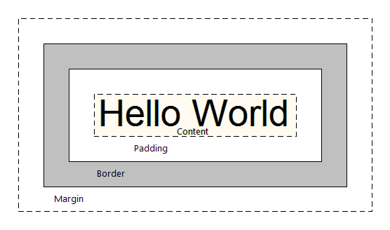**Content**

In a box model, content is what within the box to show of the box model i.e. images and text. For example, the content of the box model only says, “Hello World”. There can be pictures of anything within it. The height and length of the content box is controlled by the CSS box-sizing. This is where it can be changed depending on how big the user would like to use it.

* **Padding**

Padding is the area of that is used for the content area. It can be used to extend the area of the content. For example, if I were to say, “Hi, it is me and I am going to…”, but it is very long; I would use the padding area to cover the rest of the sentence. A picture is another example that can be used. However, this content if not used, it is transparent.

Example

padding-right:10px;

padding-top:10px

* 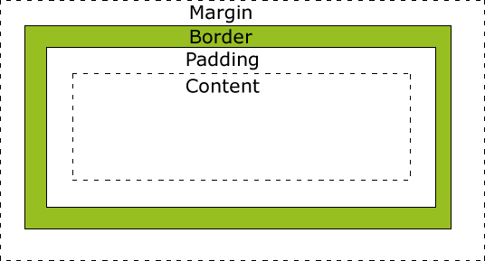**Border**

The border is used to surround the content and the padding. If the border is not used, it will be and extended version of padding. The border can be coloured depending on the size.

This covers the Padding and Content. The border can be thick and thin. An example is shown below of how border can be used. You can change the size of the border with the colour too.

Example

p {

border: 5px solid red;

}

* **Margin**

Margin is the outer layer out of all of the box model. Margin goes after border on the box model. This is transparent.

Example

p {

margin-top: 100px;

margin-bottom: 100px;

}

**HTML file used to create box**

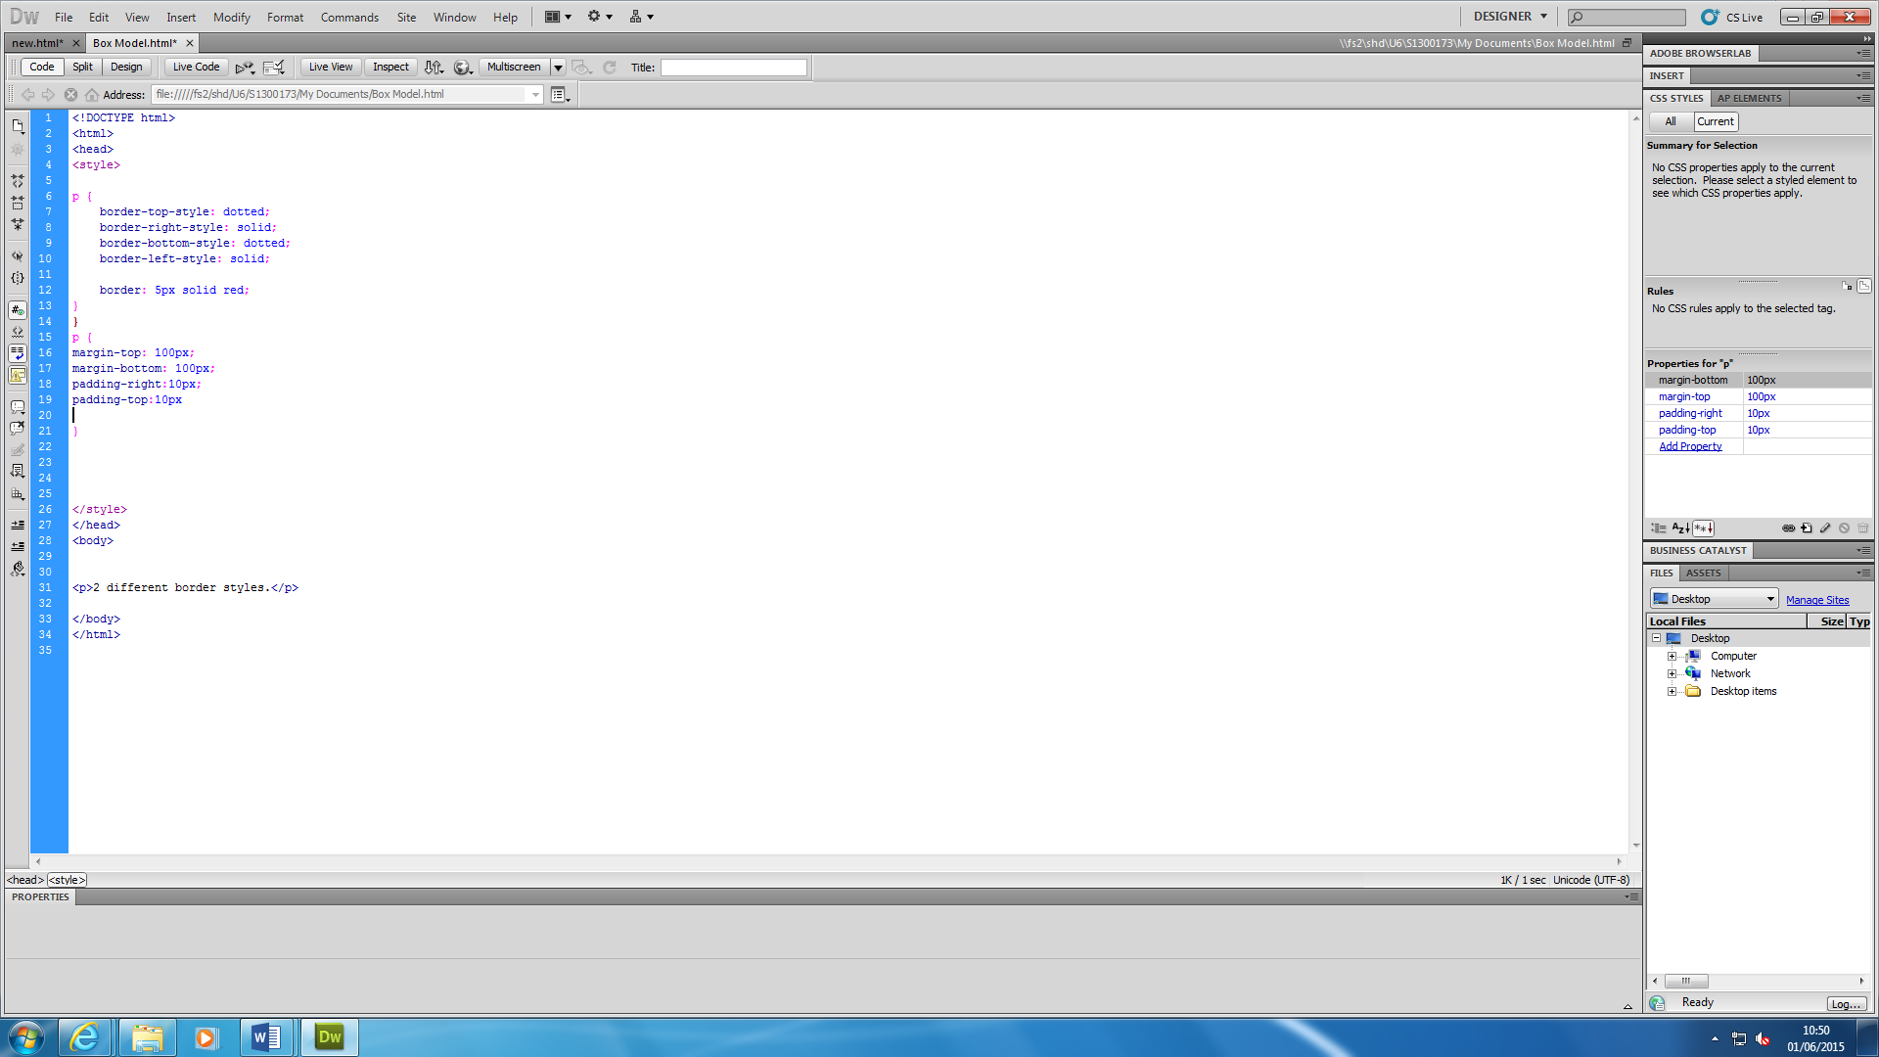

**Browser view**

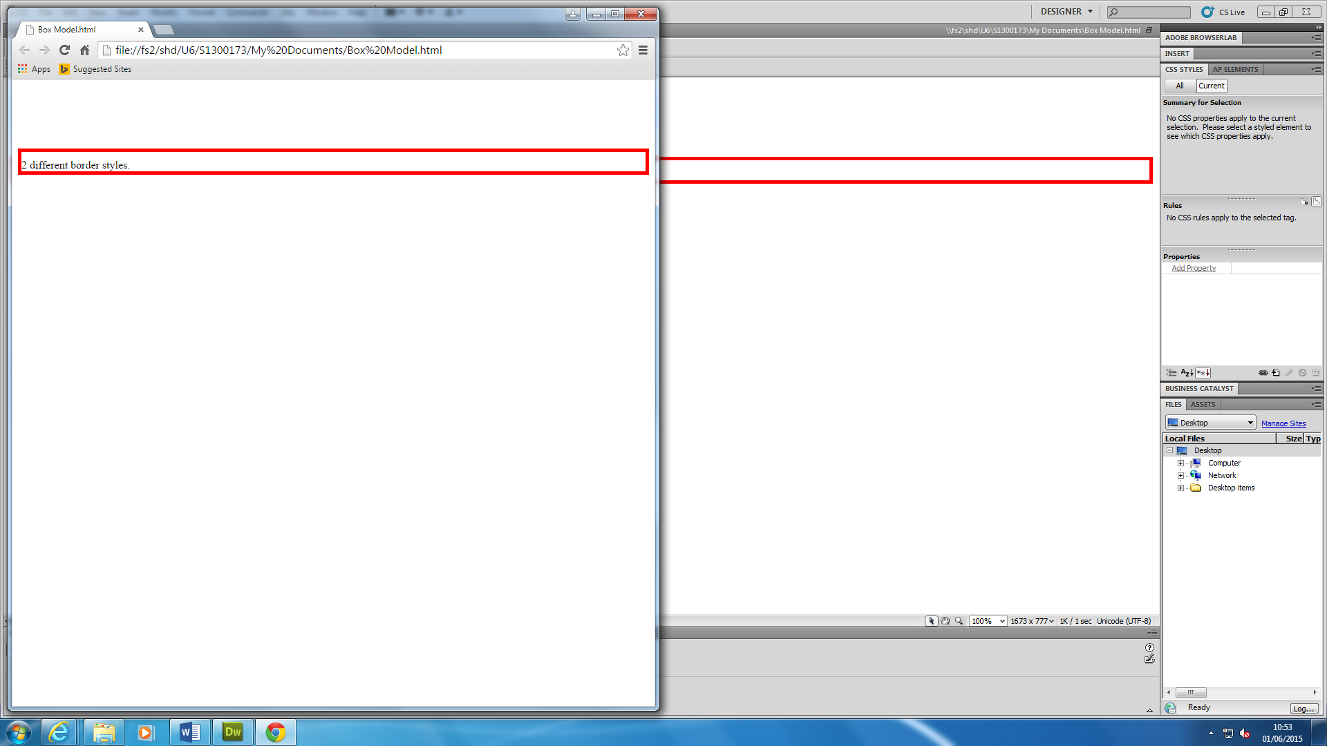

**Reference**

[**https://developer.mozilla.org/en-US/docs/Web/CSS/box_model**](https://developer.mozilla.org/en-US/docs/Web/CSS/box_model)